Module 9 – In Class Activity – Code Explanation

Oscar Garcia, Ethan Carter, Antz Claveus, and Thomas Lilchin
Department of Engineering and Technology, Miami Dade College
COP 2800: Java Programming
Dr. Martins Idahosa
April 1, 2026

In the world of object-oriented Java programming, polymorphism, interface, and inheritance are almost as interconnected as is the body, mind, and soul are. When one thinks of inheritance, just think it as a is-a relationship. This allows one class to extend and to reuse another class. One simple instance of this is Lion is an animal. An interface on the other hand is like an appendage to an already existing class.
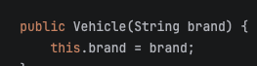
Constructors are a vital part in Java Object-Oriented Programming (OOP) because they allow us to access variables that otherwise would be protected or private to the rest of the program. For our constructor logic, we can begin explaining by going to line 51 and 52 of our program. In these lines, we assign brand and this.brand (which refers to the protected String variable of the Vehicle class named brand). The this keyboard is used to specify to the variable(s) that are a part of the class to which the constructor belongs to.

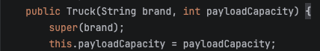
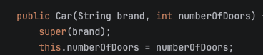
Next, we see another constructor in line 69. This Car constructor takes in the arguments of String brand and int numberOfDoors. Inside the constructor, we call the super keywork to call the brand from the super class, so it is now a part of the Car class. Then, we assigned numberOfDoors to this.numberOfDoors. Next, in line 91, we created a constructor named Truck and passed in the variables of String brand and int payloadCapactityutilize the super keyword to call the brand variable of the superclass called Vehicle. Then, we assigned the passed in payloadCapacity to the this.payloadCapacity. Finally, in line 121, we created a constructor named ElectricCar (same name as the class name). In this constructor, we called the super keyword to call the brand and numberOfDoors variables from the superclass. Then, we assigned batteryCapacity to this.batteryCapacity.

Method overriding in lay-man terms, is when a method replaces or "overrides" another method of the same name in a program. For example, we see this in lines 128 and 136 of our program. In these lines, we replace the chargeBattery and displayDetails methods presented in lines 110 and lines 98 respectively. Method overriding is quite literally what its name implies - the overriding, or replacing, of methods.


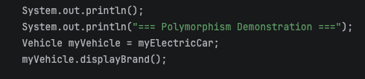
Polymorphism is an interesting concept in Java OOP. In this program, we utilize polymorphism only in one spot, which is in the polymorphism demonstration. In the code snippet seen in the right hand-side, we see a Vehicle type variable named myVehicle being assigned to myElectricCar. In this use case, we are assigning a sub-class to a super-class, which is exactly what polymorphism is. Following that assignment, we call myVehicle.displayBrand and it should display the brand of myElectricCar, which, it does! (Seen on the right screenshot).

